
THE INSTRUCTION FOR AUTHORS – THE TITLE OF THE PAPER
(TNR 13pt bold, 80pt spacing before and 15pt spacing after the last line)
(First Author) Name Surname (TNR 11pt italic), Institution
(Second Author) Name Surname (TNR 11pt italic), Institution
(Third Author) Name Surname (TNR 11pt italic), Institution
(TNR 12pt)
Abstract: This instruction provides directions for preparing the Paper for the Proceedings of the International Scientific and Professional Conference Politehnika 2025 organized by The Academy of Applied Studies Polytehnic. The authors are to prepare their papers in a technical manner, following the instructions provided in this document. The abstract should not contain more than 200 words, using the font TNR 12pt in italics. It should be written in one or more paragraphs, with alignment left and right (Justify), using the UK ENG keyboard layout. First or second person (I, me, my, we, us, our, you…) should not be used. Instead, use “this paper” or “the authors”. The abstract should not contain tables, graphs, drawings and photos, nor citations from other authors.
Keywords: Word One, Word Two, … (sorted by importance, maximum of 5 – TNR 12pt)
(TNR 12pt)
(TNR 12pt)

INTRODUCTION (The title of the chapter – TNR 12pt BOLD)
(TNR 12pt)
The complete paper (text, drawings, photographs, using author’s full name with affiliations), written in Microsoft Word, font TNR, English (UK?), should be sent to: conference@politehnika.edu.rs. The maximum length of the paper for Conference Proceedings (including drawings, photographs, tables, literature, attachments and etc.) is limited to (6) pages in A4 size (210×297mm).
(TNR 12pt)

TEXT FORMATING AND WRITTING.
(TNR 12pt)
  - Text writing (The sub-chapter title – TNR 12pt BOLD)
(TNR 12pt)
All margins in the paper should be indented by 2 cm. The text should be typed in English, TNR font (Times New Roman) 12pt using single spacing (1), with alignment left and right (Justify). The space between paragraphs should be 12pt (blank line). Pages should not be marked with numbers. Abbreviations and acronyms must be defined with the first appearance in text, regardless of their definition in the abstract. Commonly known abbreviations such as MKS, SI, TV, etc. do not need to be defined.
(TNR 12pt)
  - Expressions writing, tables and figure adjustments
(TNR 12pt)
Equations are to be prepared with Equations in MS Word should be used and not inserted as a picture. Parameters for equation typing are: font TNR, 12pt; the size of subscripts and superscripts is 10pt, the size of sub-subscripts is 8pt. Numbers, parentheses and capital Greek symbols are to be written normally (not italic), as well as operators and functions. All Latin type variables A, B, X, Y, a, b, x, y, as well as small Greek symbols α, β, γ, should be written in italic, and the vector and matric symbols Γ, A, X, are to be written in TNR Bold.

Formulas are cited in parenthesis to the right, as in this example.

$$\left(\frac{a}{b}\right) ,lnln \left(x\right),max,min,f\left(x\right)$$ | (1)

Symbols of chemical elements and units of measure for physical quantities are to be written using subscript/superscript options and are also not italic, for example:

C₂H₂ + O₂⇒ 2C + H₂ + O₂ + 0.255 MJ/mol | (2)

Explanations of variables and their measurement units shouldn’t be missed.

Figures and diagrams are to be centred. The text in figures and diagrams must be readable, therefore font TNR size 9 or 10pt should be used. Every figure/diagram to is to be marked with a number below, with the addition of short name (description), with previous reference in the text. The source should be specified below the image/diagram. If the source is a website, then the link needs to be shortened (use a short link).

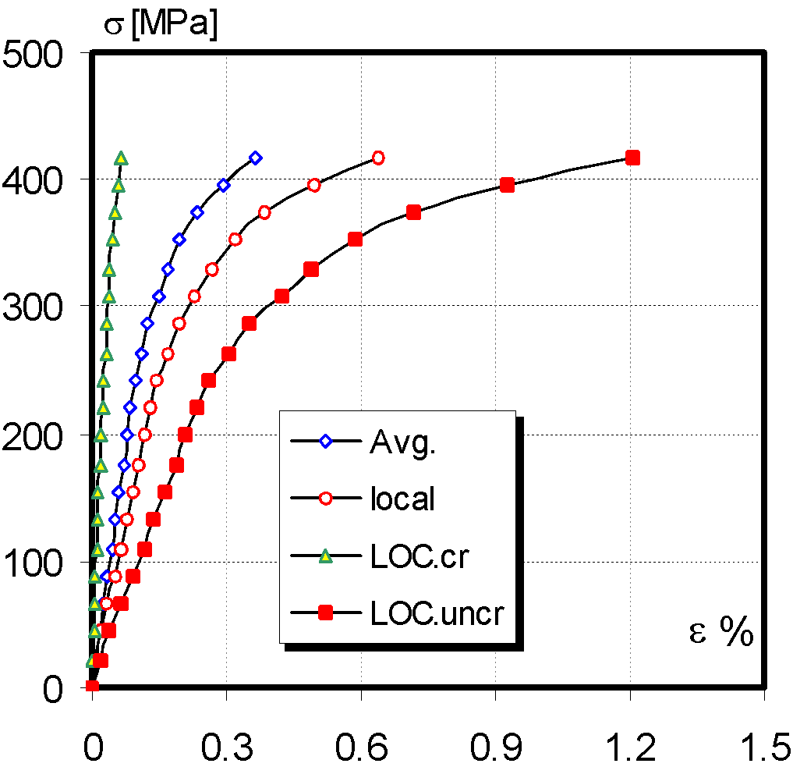
Figure 1. The Dependence of voltage-deformation TP1 (TNR 12 pt)
Source: specify the image source (TNR 10 pt)
(TNR 12pt)
Figures should be submitted as separate files, using TIF or JPEG format in case of additional editing (this especially applies to photos), or in PDF format (if they were done in CorelDraw or one of the programs from the Adobe Package).

Tables should be centred. The size of tables and the text included need to be readable, therefore the text should be written in TNR font 12pt and centred in table columns. A number and a short name (the source of the table should be indicated in brackets) is to be added above each table, with the previous reference to the table in the text. If the source is a website, then the link needs to be shortened (use a short link).

Table example:

Table 1. Geometric data (mm) (TNR 12pt)
Source: specify the data source (TNR 10pt, italic)
 |  |  | Large | Small
Surface crack |  | LSC |  | SSC
Crack depth | a | 2.5 |  | 1
Crack length | 2c | 8 |  | 8
Crack tip | r | 0.1 |  | 0.1
WM length |  | 2 |  | 2
(TNR 12pt)
Every Figure or Table must be “called out” within the text of your paper in numerical order with no abbreviations.
(TNR 12pt)
- CONCLUSION
(TNR 12pt)
Papers written in an inadequate form will be returned for additional editing. The original as-received document may be additionally formatted (editors’ choice).
(TNR 12pt)
(TNR 12pt)
Any acknowledgment to fellow researchers or funding grants should be placed within this section. This research was supported by the Organization Name [grant number xxxxxx].
(TNR 12pt)

LITERATURE
(TNR 12pt)
Literature should be specified at the end of the paper, in a special, non-numerical part. References in the text should be cited in the order of appearance in the paper, in the reference part, each reference should include Author’s surname, first letter of the name, the year of publication (TNR, small letters 11pt), and in continuation, the full title of the paper, the name of the journal or other source, the volume and number of the journal, pagination. In the text, the reference should be given in brackets [] within a sentence, e.g. [3] or at the end of the sentence e.g. [3,4,5].

Examples of referencing literature:

[1] Surname, N., Surname, N.: Name of Book (in Italics), Publisher, ISBN, Place of Publication, (YYYY).
[2] Surname, N., Surname, I.: Name of paper or Chapter, In Name of Book (in Italics), Publisher, ISBN, Place of Country, (YYYY), pp. xxx-yyy.
[3] Surname, N.; Surname, N. and Surname, N.: Title of conference paper, Proceedings of xxx xxx, Surname, N. (Ed.), pp. xxx-yyy, ISBN, conference location, Month and Year, Publisher, City, Country, (YYYY).
[4] Surname, N.: Name of Paper, Name of Journal (in Italics), Vol. (YYYY) No., pp. xxx-yyy, ISSN.

The example of referencing web pages:

[1] World Health Organization, 2023. World Health Statistics. [Internet] Available on: www.who.int/data/gho/publications/world-health-statistics (Accessed: 15.03.2023.)

NOTE:
THE AUTHORS ARE OBLIGED TO PROVIDE A SIGNED DECLARATION OF AUTHORSHIP
(scanned document)

First author email (TNR 10pt)
Second author email (TNR 10pt)
Third author email (TNR 10pt)

